# Living Mulch Trial Protocol

## Objective:

To assess if nitrogen inputs can be reduced where a clover understory is established prior to a wheat crop.

The trial will assess reduced nitrogen rates where clover is used to determine yield and grain quality, as well as full financial implications for the farm

## Assessments:

SMN tests should be taken in the autumn of 2022 prior to drilling, as well as early spring 2023, before any nitrogen inputs as well as late spring to determine how much nitrogen has been fixed by the clover.

Leaf tissue test will help to monitor crop requirements as well taking a grain sample at the end to determine final nutrient analysis.

Porous pots to monitor nitrogen leaching over winter post harvest 23.

## Trial:

Establish the clover understory between mid August and mid September when conditions allow succesful estbalishment. A low rate of roundup may be required to take out any grass weeds prior to drilling wheat (this may knock the clover a little). A control treatment should be left on one tramline with no clover. Treatment one will have a full nitrogen programme, treatment two will have 10% reduction and treatment 3 20% reduction of the total N programme. Total N rates to be confirmed when Spring SMN results come back  
Yield and grain quality (Specific weight, Protein and HFN, as well as full nutrient analysis)

**Seed rate:**

2kg/ha Small white leaf clover (33% Merwi + 66% Jura)

## Trial Protocol:

Fertiliser Programme:



## Growing Season update:

**Establishment:**

Clover established mid august via broadcasting onto a cultivated field and rolled. The clover established well despite the dry conditions at the time.

Prior to drilling the wheat 1.5l/ha roundup (360g/l) was applied due to wild oats and broad leaf weed presence. Despite being knocked the clover survived this.

The wheat was established by direct drilling into directly into the clover ley on the 8th October. This led to minimum damage to the clover as well as a well-established wheat crop. A pre emergence herbicide was applied shortly after drilling which led to a slight distortion of the clover but it grew through this.

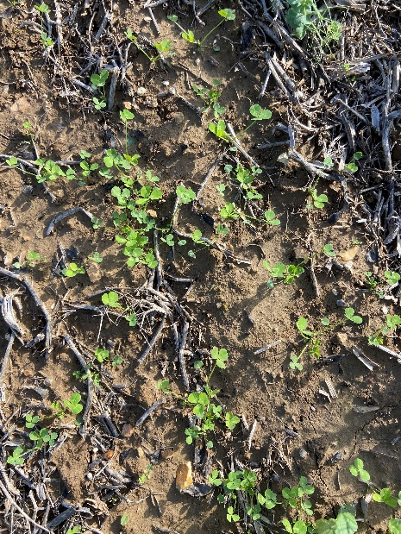

Picture 2 wheat established into clover ley following glyphosate application.

Picture 1 clover established into cultivated ground.

**Growing Season:**

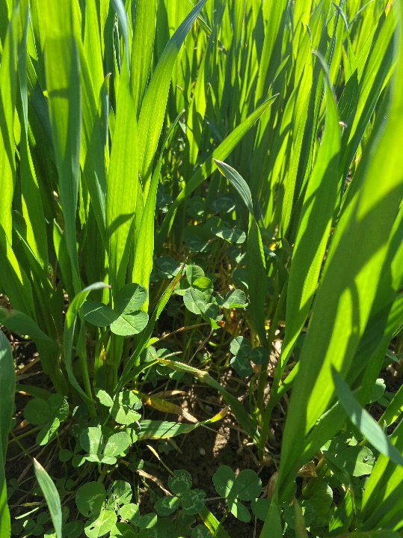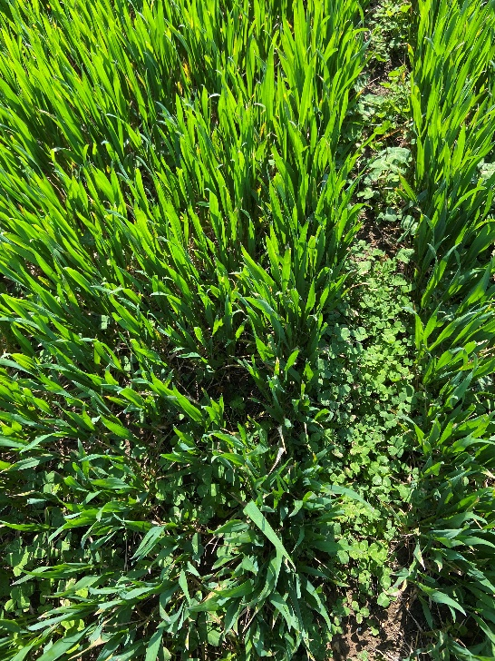The clover came through the winter well with a good plant population. Early nitrogen application to the wheat allowed the wheat to get away from the clover before any competition from the clover. By GS32 (late April) the clover started to grow more aggressively and become competitive against the wheat. A herbicide (Ally Max + CMPP) was therefore applied to prevent competition from the clover impacting the yield of the wheat as well as aiming to release the nitrogen that had been fixed from the clover.

Picture 3 clover growing prostate alongside the wheat giving greater ground cover

Picture 4 clover starting to extend and become more competitive against the wheat

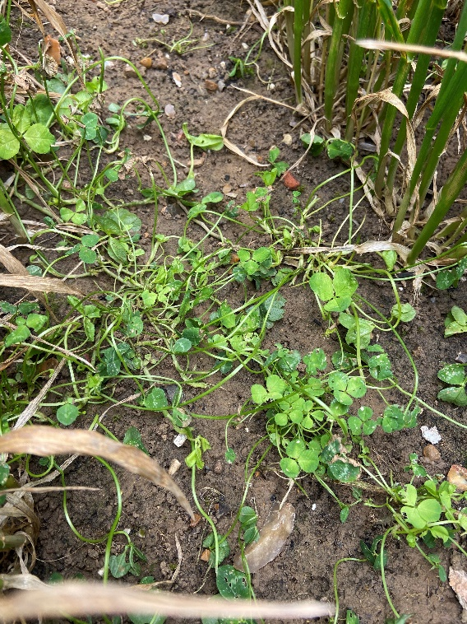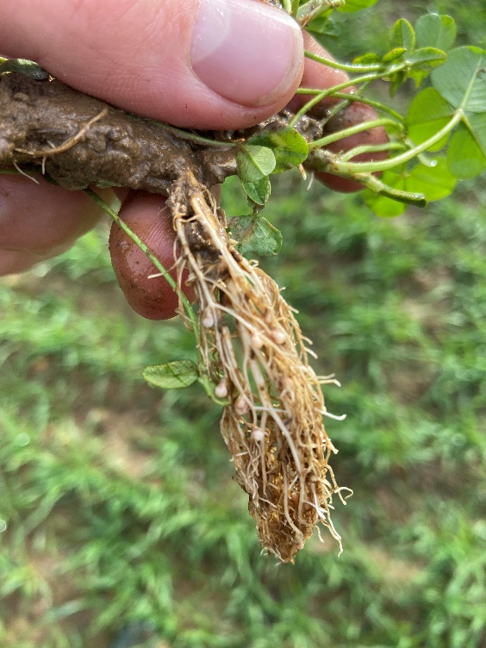

Picture 5 clover roots nodulating showing evidence of nitrogen fixation

Picture 6 clover post herbicide application twisted up and allowing the crop to get away from any competition for space and light.

In approximately 7-10 days time leaf tissue tests will be carried out to the wheat plots to determine N levels within the crop. The Yara N Tester will also be used throughout the remainder of the growing season on each plot to determine chlorophyll content of each plot.