# Living Mulch Trial Protocol

## Objective:

To assess if nitrogen inputs can be reduced where a clover understory is established prior to a wheat crop.

The trial will assess reduced nitrogen rates where clover is used to determine yield and grain quality, as well as full financial implications for the farm

## Assessments:

SMN tests should be taken in the autumn of 2022 prior to drilling, as well as early spring 2023, before any nitrogen inputs as well as late spring to determine how much nitrogen has been fixed by the clover.

Leaf tissue test will help to monitor crop requirements as well taking a grain sample at the end to determine final nutrient analysis.

Porous pots to monitor nitrogen leaching over winter post harvest 23.

## Trial:

Establish the clover understory between mid August and mid September when conditions allow succesful estbalishment. A low rate of roundup may be required to take out any grass weeds prior to drilling wheat (this may knock the clover a little). A control treatment should be left on one tramline with no clover. Treatment one will have a full nitrogen programme, treatment two will have 10% reduction and treatment 3 20% reduction of the total N programme. Total N rates to be confirmed when Spring SMN results come back  
Yield and grain quality (Specific weight, Protein and HFN, as well as full nutrient analysis)

**Seed rate:**

2kg/ha Small white leaf clover (33% Merwi + 66% Jura)

## Trial Protocol:

**Fertiliser Programme:**



## Growing Season update:

**Establishment:**

The clover was established late august with a John Deere 750A direct drill into a lightly cultivated field and rolled after Spring Oats. Due to the lack of moisture at the time of drilling the clover establishment was very slow and poor. Establishment was variable across the field. When it did rain, spring oat volunteers led to early competition so had to be removed with a graminicide.

Prior to drilling the wheat 1.5l/ha roundup (360g/l) was applied due to the presence of grass weeds and broad leaf weeds. Despite being knocked the clover survived this.

The wheat was established by direct drilling into directly into the clover ley early October. This led to minimum damage to the clover as well as a well-established wheat crop. A pre-emergence herbicide was applied shortly after drilling which led to a slight distortion of the clover but it grew through this. However as the clover was still small at the time of drilling, some of the clover was more severely damaged.

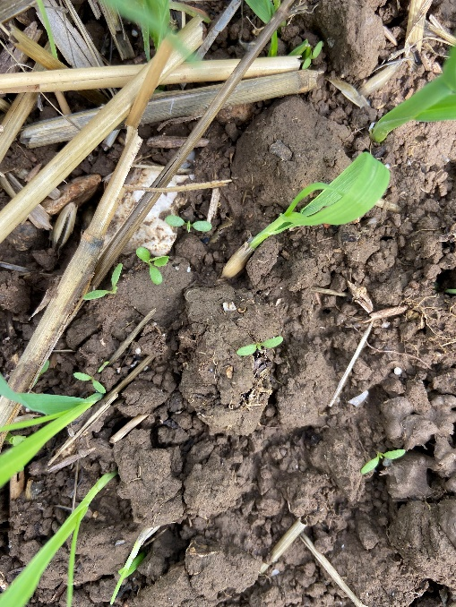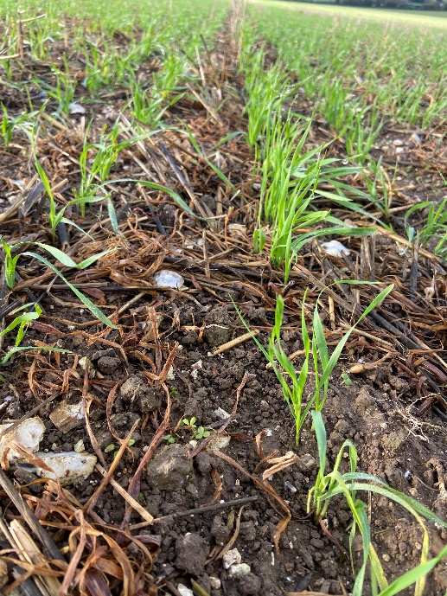

Picture clover establishing with weed pressure from volunteer spring oats and other broadleaf weeds

Picture wheat direct drilled into the clover ley, the roundup and pre emergence herbicide application has knocked the small clover plants

The clover came through the winter without putting on much growth with a low plant population. Frosts in January led to surface frost heave with damaged the rooting of small plants and led to a further thinned out plant population. Unfortunately due to the grass weed pressure of brome in the wheat field, an application of an SU herbicide late in March was applied (0.5l/ha of Pacifica Plus). This unfortunately knocked the clover further which led to poorer rooting and less nodulation and therefore less nitrogen fixation.

Picture clover struggling to get going, frosts in January further thinning out the plant population

In approximately 7-10 days time leaf tissue tests will be carried out to the wheat plots to determine N levels within the crop. The Yara N Tester will also be used throughout the remainder of the growing season on each plot to determine chlorophyll content of each plot.